PSA Hermes Transition

Application Overview Document

[Note: The following template is provided for use with all ADC systems development projects. Text enclosed in square brackets and displayed in blue italics (style=InfoBlue) is included to provide guidance to the author and should be deleted before publishing the document. A paragraph entered following this style will automatically be set to normal (style=Body Text).]

[To customize automatic fields (which display a gray background when selected), select File>Properties and replace the Title, Subject and Company fields with the appropriate information for this document. After closing the dialog, automatic fields may be updated throughout the document by selecting Edit>Select All (or Ctrl-A) and pressing F9, or simply click on the field and press F9. This must be done separately for Headers and Footers. Alt-F9 will toggle between displaying the field names and the field contents. See Word help for more information on working with fields.

The following data is stored in the corresponding fields:

Client Name: Custom.Client

Project Name: Custom.Project

Author: Summary.Author

Approver Custom.Checked by

Version Custom.Disposition]

**Document Control**

Revision History

|  |  |  |  |
| --- | --- | --- | --- |
| **Date** | **Version** | **Author** | **Description** |
| 17/08/2016 | 1 | Krishnapriya | Creation of document for Application **PARC ROULANT** |
|  |  |  |  |
|  |  |  |  |
|  |  |  |  |

Distribution

|  |  |  |  |
| --- | --- | --- | --- |
| **Name** | **Title** | **Document Version** | **Date** |
|  |  |  |  |
|  |  |  |  |
|  |  |  |  |
|  |  |  |  |
|  |  |  |  |

Approval Signatures

|  |  |  |  |  |
| --- | --- | --- | --- | --- |
| **Name** | **Title** | **Document Version** | **Signature** | **Date** |
|  |  |  |  |  |
|  |  |  |  |  |
|  |  |  |  |  |
|  |  |  |  |  |

**Table of Contents**

OBJECTIVES 5

1. Business 6

1.1. Business Overview 6

1.2. Business Processes 6

1.3. Business Interrelationships 6

1.4. Business Criticality 6

2. Functional 6

2.1. Functional Overview 6

2.2. Functional Details 7

2.3. Data Flow 7

3. TECHNOLOGY RELATED 7

3.1. Technical Overview 7

3.2. Application Architecture 8

3.3. Application Platform 9

3.4. Source Code Control 9

3.5. Production, UAT and Development Locations 9

3.6. Hardware and Software Pre-requisites 9

3.7. Interfaces to other systems 9

3.8. Documentation 10

3.9. Network Specific Issues 10

3.10. Third Party Tools 10

4. Technical Environment 10

4.1. Server Names 10

4.2. Web Locations 10

4.3. Web URLs 10

4.4. On-Line Region 10

4.5. Libraries 10

4.6. Software Requirements 10

4.7. Server/Application access requirements 10

4.8. Login IDs on Production and Development 10

4.9. Test data and Test environment 10

4.10. Change Control Procedure 10

4.11. Forms 10

4.12. Reports 10

4.13. Tools 11

4.14. Methodologies 11

4.15. Complexity 11

4.16. Unusual coding practice 11

4.17. Commonly used routines 11

5. Datasets & Databases 11

5.1. Overview 11

5.2. Tables 11

5.3. Stored Procedures 11

5.4. User-Ids 11

5.5. Performance Requirements 11

6. Application Components 11

6.1. Naming Standards 11

6.2. Batch 11

6.3. On-Line 11

6.4. Other objects 11

7. OPERATIONAL REQUIREMENTS 11

7.1. Application Administration 11

7.2. DR Process & documentation 11

7.3. Daily, Weekly, Monthly, Quarterly, Monthly Checks/Activities 11

7.4. On Demand/Request 12

7.5. Backup Information 12

8. PROCESS RELATED 12

8.1. Change Control 12

8.2. Problem Management 12

8.3. Release Management 12

8.4. Size/Complexity/Criticality 12

8.5. Coding Standards 12

9. CONTACT INFORMATION 13

9.1. Business Contacts 13

9.2. Support Team Contacts 13

9.3. Third Parties Contact Information 13

9.4. Client Support 13

9.5. Infrastructure (Server/Network) 13

9.6. DBAs 13

9.7. Other contacts 13

10. PROBLEM REPORTING 13

10.1. Helpdesk details 13

10.2. Vendor Details 13

11. APPLICATION HISTORY 13

11.1. Typical Problems 13

11.2. Tips & Tricks 13

11.3. Application Release History 13

12. GLOSSARY 14

13. REFERENCE DOCUMENTS 14

# **OBJECTIVES**

The objective of the Application Overview Document (AOD) is to provide members of the delivery team with an overview of the application. The AOD describes the function of the application, the structure of the applications, the application configuration and the technical environment. This document will refer to any existing related documentation.

The AOD will be used to support the application and will always be kept current throughout the life of the application.

# 

# **Business**

Business Overview

The purpose of this document is to provide the overview of **PARC ROULANT** application, so as to be used as reference by team for knowledge transfer or while handling any related subjects.

Business Processes

The purpose of PARC ROULANT application is:

* + - To integrate the vehicle data of origin POLK and PSA
    - To calculate the estimated or reconstitution of group of vehicles.
    - To generate reportings on the group of vehicle data calculated (travelling/estimated/specific).

Business Interrelationships

This application merges the Vehicle data from POLK and PSA(Fracturations,Immatriculations,Previsions moyen terme AC, Previsions moyen terme AP,Previsions Strategiques, Parc specifiques) and to generate reports..

Business Criticality

To view the Statistical calculation of Vehicles data.

# **Functional**

Functional Overview

The administrator imports all the vehicles data coming from different applications to the parc application and the users can export or view the vehicle data.

Functional Details

There are two roles in this application.

Adminstrator and Users.

Adminstrator :To calculate the parc (group of vehicles statistical calculation) and effects of parc.

* + - AP, AC for all the countries (approximately 160)

User : Do Queries on the parcs in an autonomous way.

* + - Total parcs all brands bought with POLK for 43 countries
    - Parcs AP, AC calculated by BEING (Parcs budgets).

In order to be able to calculate parcs AC and AP starting from the various data sources it is imperative that the format of the data is homogeneous from one source to another.

1.**Import Menu :**

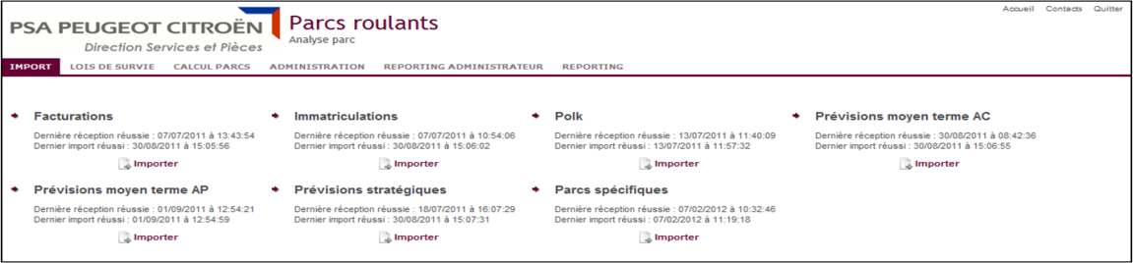

Polk file:

Only fields FUEL_TYPE (ENERGY), VEH_TYPE (KIND), MANUF (BRAND), COUNTRY (COUNTRY) and MODEL/BODY_TYPE (MODELE_COMPLET) are transformed at the time of the importation.

The file Polk has the following format.

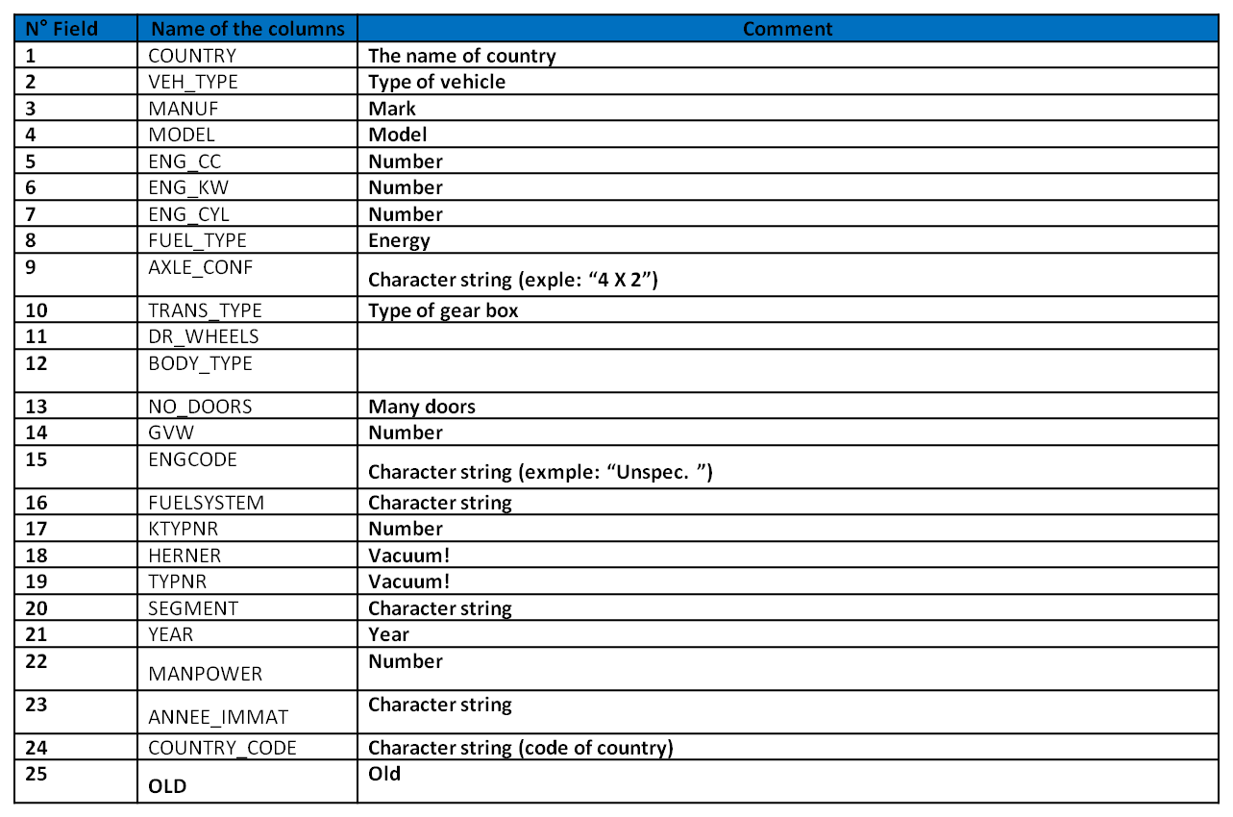

File Registration:

Only the fields MARKS, COUNTRY, ENERGY, KIND, YEAR MODELS and CAR BODY (MODEL/CAR BODY will give MODELE_COMPLET) are transformed at the time of the importation.

The file Registration has the following format.

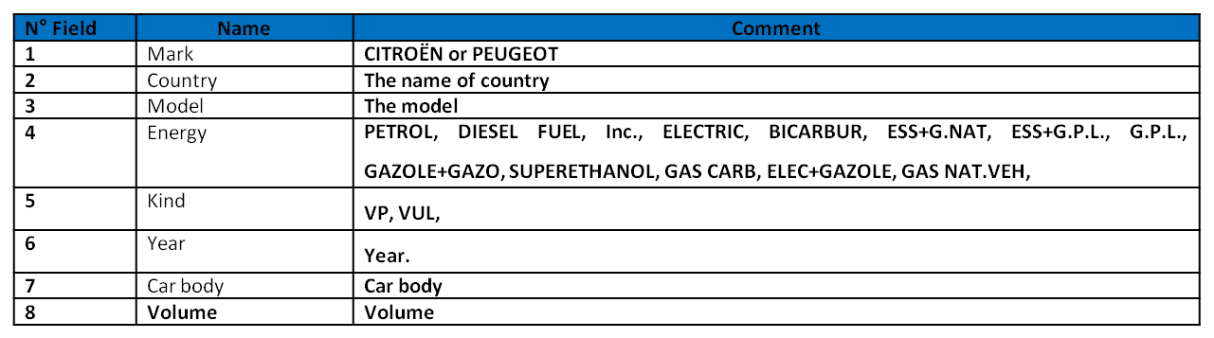

File Invoicing:

Only the fields MARKS,COUNTRY,ENERGY,KIND and FAMILLE_LIB/CARROSSERIE (KIND and FAMILLE_LIB/CARROSSERIE will give MODELE_COMPLET) are transformed at the time of the importation.

The file Invoicing has the following format.

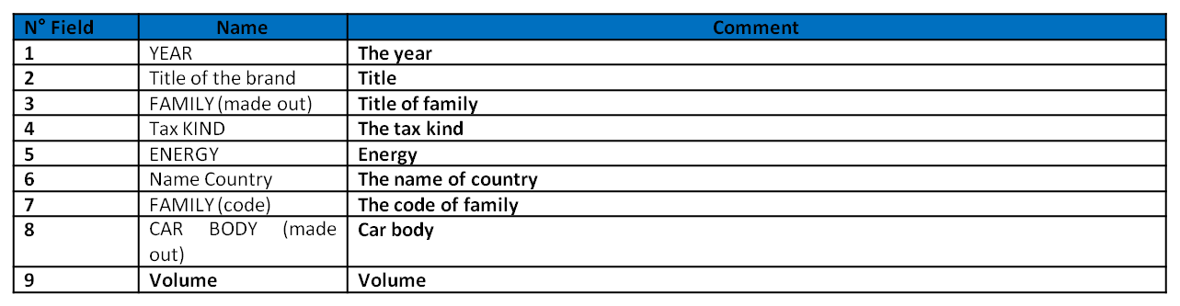

Files Forecasts Medium term (AP and AC):

Only the fields MARKS, COUNTRY, KIND and MODEL (KIND and MODEL will give MODELE_COMPLET) is transformed at the time of the importation.

The file Forecasts Medium term (AP and AC) has the following format.

|  |  |  |
| --- | --- | --- |
| **N° Field** | **Name** | **Comment** |
| **1** | Country | **The name of country** |
| **2** | Kind | **The kind** |
| **3** | Model | **The model** |
| **4** | January | **Data for January** |
| **5** | February | **Data for February** |
| **6** | March | **Data for March** |
| **7** | April | **Data for April** |
| **8** | May | **Data for May** |
| **9** | June | **Data for June** |
| **10** | July | **Data for July** |
| **11** | August | **Data for August** |
| **12** | September | **Data for September** |
| **13** | October | **Data for October** |
| **14** | November | **Data for November** |
| **15** | December | **Data for December** |
| **16** | **Year** | **Data for the year** |

File Strategic Forecasts:

Only the fields MARKS, COUNTRY, KIND and LIB_VEH (KIND and LIB_VEH will give MODELE_COMPLET) are transformed at the time of the importation.

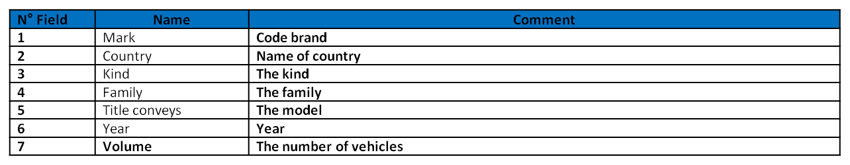

Specific files Parcs:

Only the fields MARKS, COUNTRY and KIND is transformed at the time of the importation.

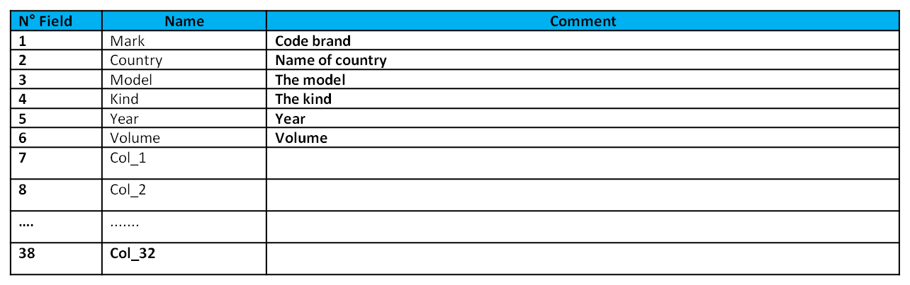

Importing is done in the parc from the files Invoicings/Registrations/Polk as shown in fig.

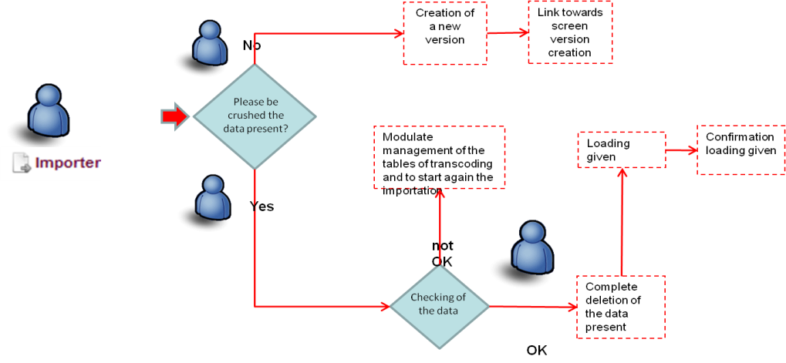

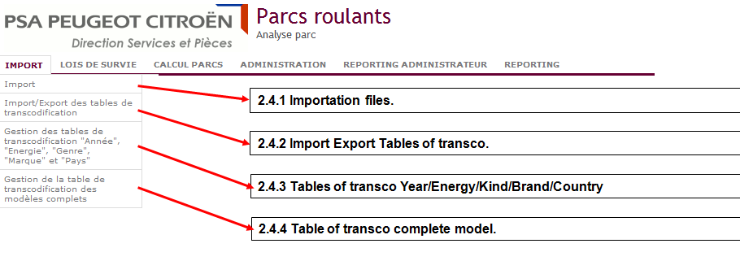

* Import : Importation of files.
* Import/Export of Transcodifiaction : To import and export tables of Transco.
* Tables of transco year /Energy/Kind/Brand/Country.
* Table of transco complete model.

2. Lois De Survie Menu :

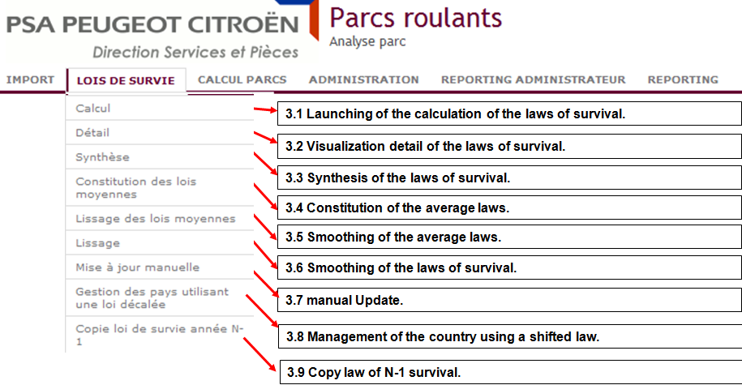

* Calcul : Launching of the calculation of the laws of survival.
* Detail: Visualization detail of the laws of survival.
* Synthese: Synthesis of laws of survival.
* Constitution of average laws.
* Smoothing of average laws.
* Smoothing of the laws of survival.
* Maual update.
* Management of the countryusing a shifted law.
* Copy law of N-1 survival.

Calcul Parcs Menu:

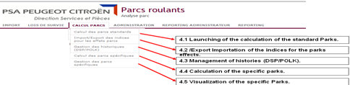

4.Administration Menu:

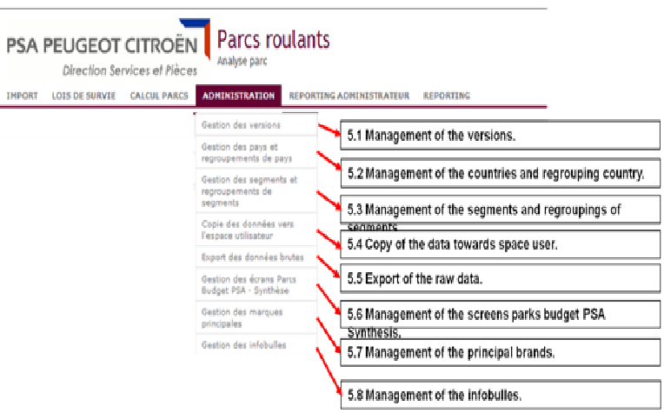

This page makes it possible to export the raw data of invoicings, registrations, POLK, medium term forecasts, strategic forecasts, sales and parks effects via links.

The formats of the files are the following:

**Invoicings**: TYPE; MARK; COUNTRY; KIND; MODELE_COMPLET; ENERGY; YEAR; VOLUME

**Registrations**: TYPE; MARK; COUNTRY; KIND; MODELE_COMPLET; ENERGY; YEAR; VOLUME

**POLK**: TYPE; MARK; COUNTRY; KIND; MODELE_COMPLET; ENERGY; ANNEE_PARC; ANNEE_IMMAT; OLD; VOLUME

**Forecasts medium term**: TYPE; MARK; COUNTRY; KIND; MODELE_COMPLET; VOLUME

**Strategic forecasts**: TYPE; MARK; COUNTRY; KIND; MODELE_COMPLET; YEAR; VOLUME

**Sales**: TYPE; MARK; COUNTRY; KIND; LIB_TYPE_DONNEES; YEAR; Sales VOLUME with complete models, segment and energy:

TYPE; MARK; COUNTRY; KIND; COMPLETE MODEL; SEGMENT; ENERGY; YEAR; LIB_TYPE_DONNEES; VOLUME

**Parks effects**: TYPE; MARK; COUNTRY; YEAR NR; N+1 YEAR; VOLUME EFFECT; OLD EFFECT; ROUTING EFFECT; FIDELITY EFFECT; PARK EFFECT

5.**Reporting Administrateur :**

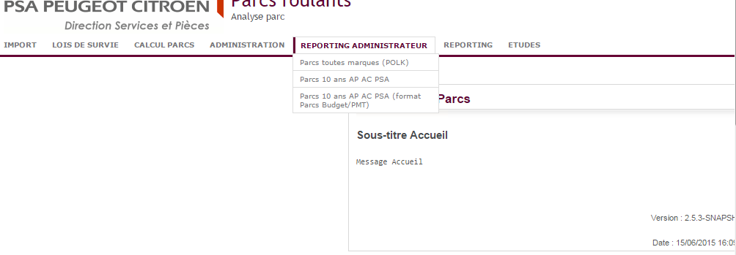

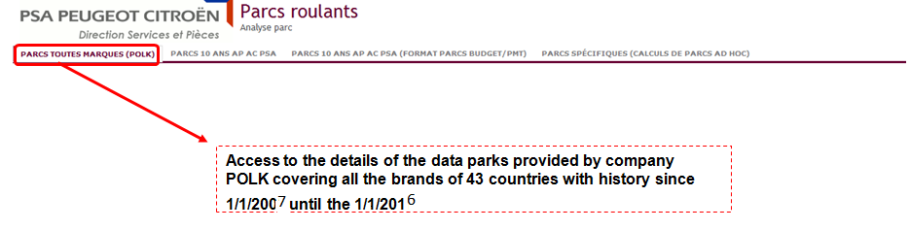

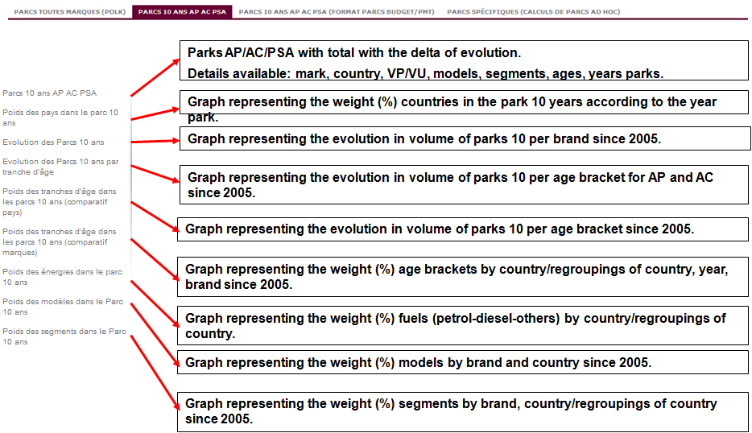

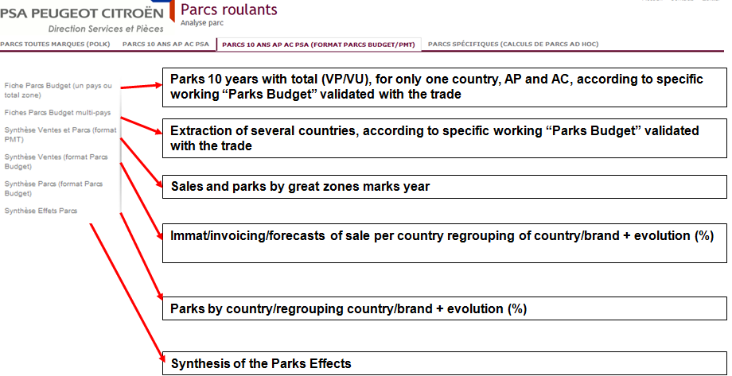

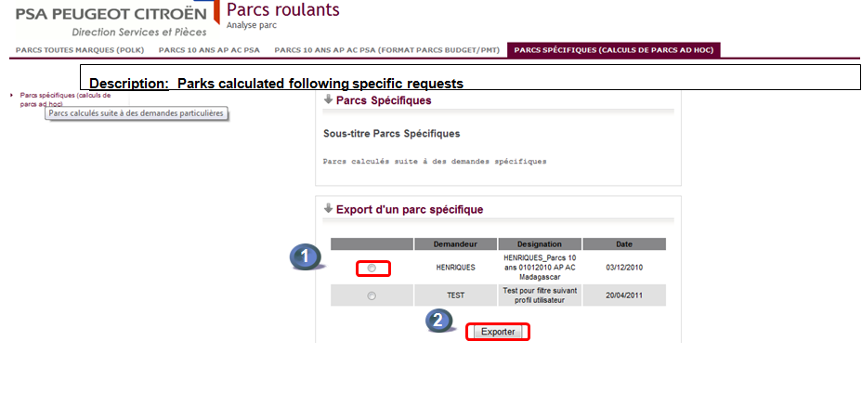

Data Flow:

The vehicle related information from different applications which are are in file format is imported into parc and after performing some calculations, the data can be viewed in the form of reports as shown in the diagram.

The files are uploaded using Conect Express Tool.

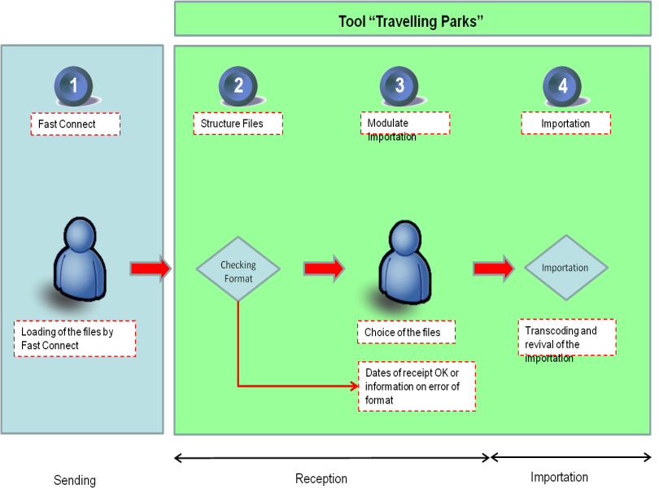

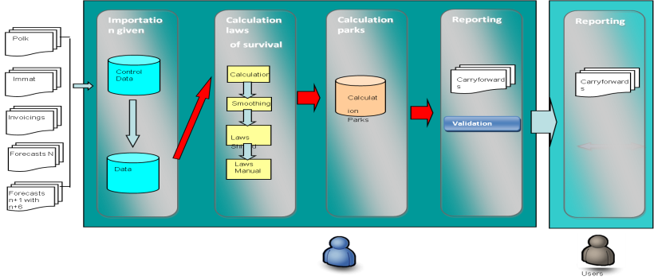

# **TECHNOLOGY RELATED**

Technical Overview

Technologies used are the following ones:

Java 5

Glassfish

JS/JQuery

Struts 2.3

Spring 3.1.4

Lego 3.10

Oracle 11g

Application Architecture

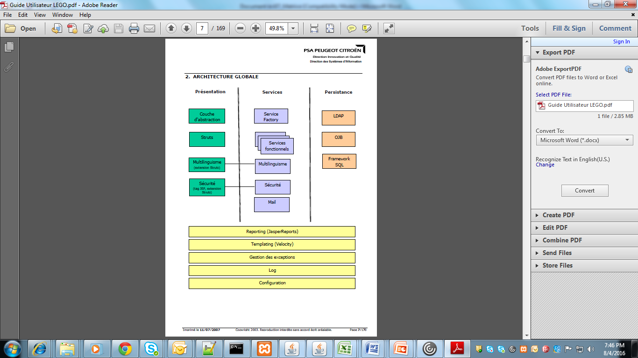

Source Code Control

Main svn location : <http://svn.informatique.inetpsa.com/svn/par00/Etudes>

Production, UAT and Development Locations : done

URLs for HUB : NA

Accounts :

Hardware and Software Pre-requisites

Interfaces to other systems: No Interfaces or Batches .



Documentation

Network Specific Issues : No Specific point discussed on it.

Third Party Tools

Connect Express Tool

# **Technical Environment**

Server Names :

|  |  |  |  |
| --- | --- | --- | --- |
|  | Production | Pre-Prod | Dev |
| UI | YVASH190 | YVASH110 | yvasb790 |
|  |  |  |  |

**Unix server PSA of Dev.:**

Host: yvasb790

Log-on: mdepar00

Password: parmde00

**Console Glassfish of Dev.:**

Host: <https://yvasb790.inetpsa.com:4848/>

Log-on: mdepar00

Password: mdepar00

**Access to the logs batch and front end of prod/preprod:** (Not Working will get soon from pilot)

<http://consultlog.inetpsa.com/index.php>

BU : DC2S

Application: PARC-ROULANT

Server: YVASH190

User: mzppar00

Web Locations

**Prod:**

URL: <http://parc-roulant.inetpsa.com/accueil>

**Préprod:**

URL: [http://parc-roulant.preprod.inetpsa.com](http://parc-roulant.preprod.inetpsa.com/)

**Dev.:**

URL: [http://parc-roulant.dev.inetpsa.com](http://parc-roulant.dev.inetpsa.com/)

Web URLs

**Prod:**

URL: <http://parc-roulant.inetpsa.com/accueil>

**Préprod:**

URL: [http://parc-roulant.preprod.inetpsa.com](http://parc-roulant.preprod.inetpsa.com/)

**Dev.:**

URL: [http://parc-roulant.dev.inetpsa.com](http://parc-roulant.dev.inetpsa.com/)

On-Line Region

France

Libraries

Software Requirements

Server/Application access requirements

Login IDs on Production and Development

You can use your own credential for login(PSA credentials)

Test data and Test environment :

No Testing Environment. Even Junit is also not used.

Change Control Procedure

* Using SVN,Jira,SDI.
* For any new version in Production, raise a change request in SDI.
* Then INDUS team will pick up the stable dev build from CIQ.

Forms - NA

Reports - Yes

Tools

SQL Developer

WinSCP

Methodologies

Complexity: It is a silver application with DICT Value 1121. No complexity in terms of coding or application.

Unusual coding practice

this application is using Stored procedures.s

Commonly used routines

No specific point discussed about it.

# **Datasets & Databases**

Overview

Tables

PARQTAPO1

PARQTCLS1

PARQTTFA

PARQTLFA

PARQTTIM

PARQTTCIM

PARQTTPO

PARQTTVMO

PARQTTVS

PARQTTSP

PARQTSPO

PARQTCVM

Stored Procedures : Yes, Stored procedures are available.

User-Ids

|  |  |  |  |
| --- | --- | --- | --- |
| **TBD** | **Production** | **Pre-Prod** | **Dev** |
| **User** | etudes | etudes (development team) | Par |
| **Mdp** | etudes | etudes | Par |
| **Hostname** | yvash190 | yvash110 | yvasb790 |
| **Port** | 1521 | 1521 | 1521 |
| **BDD** | PAR00 | PAR00 | PAR |

Performance Requirements

No specific point discussed about it.

# **Application Components**

Naming Standards

No specific point discussed about it.

Batch - NA

On-Line

Other objects

# **OPERATIONAL REQUIREMENTS**

Application Administration

No specific point discussed about it.

DR Process & documentation

Indus team might have details regarding this.

Daily, Weekly, Monthly, Quarterly, Monthly Checks/Activities - NA

On Demand/Request

No specific point discussed about it.

Backup Information

No specific point discussed about it.

# **PROCESS RELATED**

Change Control

* Using SVN,Jira,SDI.
* For any new version in Production, raise a change request in SDI.
* Then INDUS team will pick up the stable dev build from CIQ.

Problem Management

The Support Team needs to take action.

Release Management

Indus Team will do the release.

Size/Complexity/Criticality

Coding Standards

No specific point discussed about it.

Metrics

**CONTACT INFORMATION**

Business Contacts - Xavier Riou

Contacts

CPI (IT Project Manager) : No specific point discussed about it.

Support Team Contacts

Third Parties Contact Information

No specific point discussed about it.

Client Support

No specific point discussed about it.

Infrastructure (Server/Network)

No specific point discussed about it.

DBAs

No specific point discussed about it.

Other contact

No specific point discussed about it.

# **PROBLEM REPORTING**

Helpdesk details

No specific point discussed about it

Vendor Details

No specific point discussed about it.

# **APPLICATION HISTORY**

Typical Problems

No specific point discussed about it.

Tips & Tricks

No specific point discussed about it.

Application Release History

|  |  |  |  |  |  |
| --- | --- | --- | --- | --- | --- |
| Date | Version | Full/Upgrade | Released to Locations | Description | Release Made By |
| 16/06/15 | 2.5.4 | Full deployment(Migration from oracle 10g to 11g) |  |  |  |

# **GLOSSARY**

|  |  |
| --- | --- |
| Acronym | Description |
|  |  |
|  |  |
|  |  |
|  |  |
|  |  |
|  |  |

# **REFERENCE DOCUMENT**

Templates

NO Specific templates mentioned during KT